**Part IX: Chapter 10: Linear Regression Relationships**

**Task 1: In Part II, you created a scatterplot of Year vs. Number of Police-involved Deaths which looked like this:**

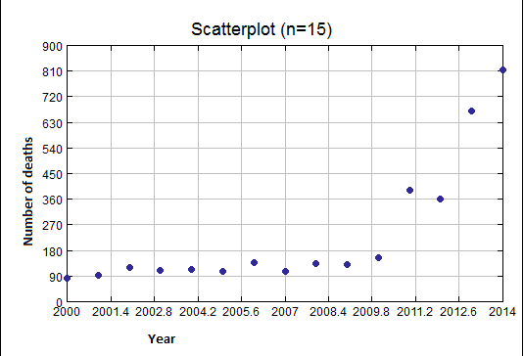

**That scatterplot was based on the data table below:**

|  |  |
| --- | --- |
| **Year** | **Number of police involved deaths** |
| **2000** | **83** |
| **2001** | **94** |
| **2002** | **120** |
| **2003** | **110** |
| **2004** | **114** |
| **2005** | **105** |
| **2006** | **138** |
| **2007** | **105** |
| **2008** | **134** |
| **2009** | **132** |
| **2010** | **156** |
| **2011** | **391** |
| **2012** | **359** |
| **2013** | **669** |
| **2014** | **815** |

* **Run a linear regression test on this data. Report the correlation coefficient, Pearson critical values, and write the equation for the linear relationship.**
* **Determine if there is a valid linear relationship.**

**Task 2:**

* **Does it appear that another mathematical model might better fit this data? Speculate on what kind of model could be a better fit than a linear model.**

**Task 3:**

* **We will use a calculator to run an exponential regression for this data. Do to this put the data into the editor lists first. You will need to put use “years since 2000” instead of the actual year to avoid an overflow error. So the data will be put in like this:**

|  |  |
| --- | --- |
| **Years since 2000 (in L1)** | **Number of Police-involved Deaths** |
| **0** | **83** |
| **1** | **94** |
| **2** | **120** |
| **3** | **110** |
| **4** | **114** |
| **5** | **105** |
| **6** | **138** |
| **7** | **105** |
| **8** | **134** |
| **9** | **132** |
| **10** | **156** |
| **11** | **391** |
| **12** | **359** |
| **13** | **669** |
| **14** | **815** |

**Now go to STAT then over to CALC and choose ExpReg, hit ENTER.**

**Type “L1, L2”, so that the full command reads: ExpReg L1, L2.**

* **Report the correlation coefficient and write the equation for the exponential relationship.**
* **By comparing the “r” values, does this appear to be a better mathematical relationship?**